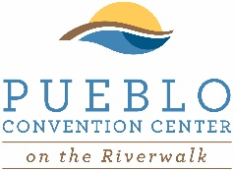
2022 BRIDAL EXPO
Pueblo Convention Center
320 Central Main Street | Pueblo, CO 81003
www.puebloconventioncenter.com
p: 719-542-1100 | f. 719-583-9351
Exhibitor Order Form
Company Name:
Contact:
Street:
City: State: Zip:
Phone: Fax:
eMail:
Type of Business:
Hundreds of couples come through our doors every year to gain insight and ideas to help make their day not only memorable, but exquisite. Come and showcase your business, professionalism and expertise by becoming one of our preferred vendors. This event is open to the public and free of charge. Vendors who provide a door prize will receive at least (1) mention on social media prior to the event. Sign up today and display what you do best.
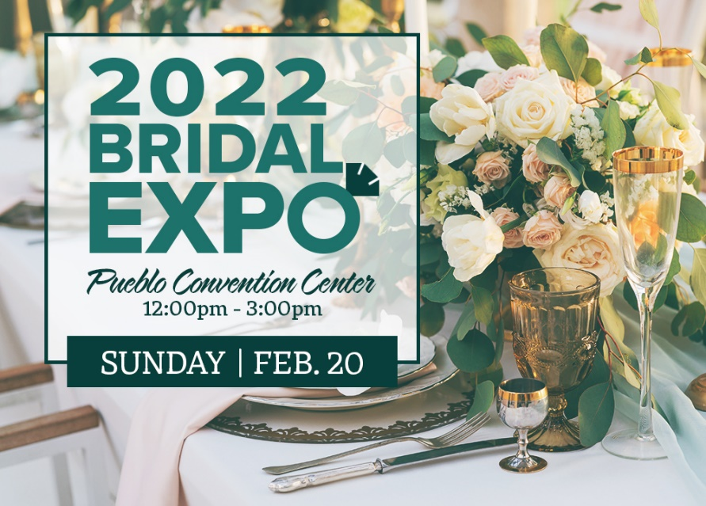
Presenting Sponsor - $2,000
Gold Sponsor - $1,000
8x8 Booth (includes pipe and drape, linens,
(1) 6ft table, (2) chairs, (1) trash can) - $300
8x16 Booth (includes pipe and drape, linens,
(2) 6ft tables, (2) chairs, (2) trash cans) - $400
Electricity - $55
Additional Table - $17
Total Due:
Will you provide a door prize? Y N
Door Prize Value - $
** Payments due prior to event Load In. NO EXCEPTIONS.
Vendor Insurance: We suggest all vendors carry vendor insurance. The overall insurance for the event does not personally cover you or your employees. Many companies can provide vendor insurance such as ACT Insurance at www.actinsurance.com. Indemnification: Licensee hereby agrees to indemnify, defend, and hold harmless Licensor and the owner, and their respective officials, officers, directors, agents, employees, successors and assigns from and against any an all claims, damages, expenses, costs (including, without limitation, reasonable attorneys’ fees) and liabilities (collectively, “claims”) arising or alleged to arise from (i) any breach of this agreement by licensee. Cancellation: Vendors may cancel their booth more than 90 days prior to the event and receive a full refund. A 50% refund will be provided if cancelled between 30-90 prior to the event. No refunds will be provided for booths canceled within 30 prior to the event.
Signed:
LOAD IN: February 20, 2022 | 9:00am – 11:30pm
EVENT: February 20, 2022 | 12:00pm – 3:00pm
LOAD OUT: Immediately Following the Event
Print:
Date:
2022 BRIDAL EXPO
Pueblo Convention Center
320 Central Main Street | Pueblo, CO 81003
www.puebloconventioncenter.com
p: 719-542-1100 | f. 719-583-9351
VENDORS: Please provide your 3 top booth locations, in order of preference. We will do our best to place you in your first choice location whenever possible. We will also do our best to separate direct competitors or business that promote similar products and services.
Vendor Name:

Please List Competitors:

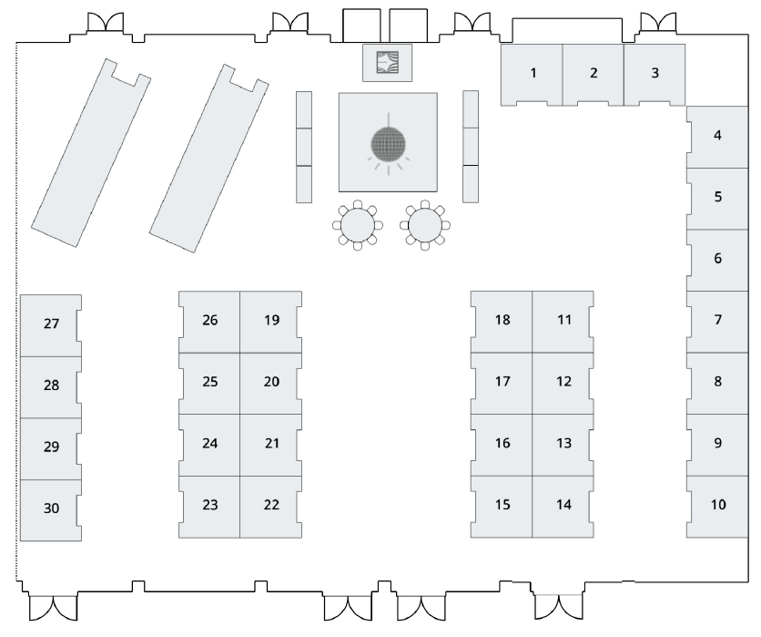
Please List the Types of Products/Services you will promote:
Booth 1st Choice:

Booth 2nd Choice:

Booth 3rd Choice:

Sponsorships & Booth Packages
Presenting Sponsor - $2,000
- Logo include with event branding on all materials
- Logo on 250 attendee bags
- Logo and mentions included on website and Facebook page
- Advertisement to 8,000 email subscribers
- Logo included on promotional posters, flyers, and print ads
- Event signage & banners throughout the venue
- 8x16 booth space at the event
Gold Sponsor - $1,000
- Logo included on promotional posters, flyers & print ads
- Event signage & banners throughout the venue
- 8x8 booth space at the event
Booth Space | 8x8 ($300) or 8x16 ($400)
- 6 foot table with (2) chairs
- Table linen
- 1 electrical connection
- Pipe and drape

